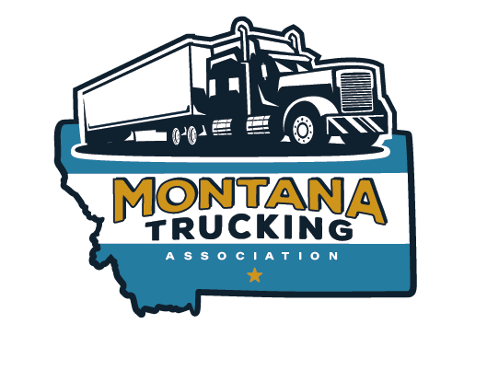

MONTANA TRUCKING ASSOCIATION

501 NORTH SANDERS #201 HELENA MT 59601 406-442-6600 www.mttrucking.org

2025 Annual Convention-Billings

Shifting the Economy Forward

***Monday September 29, 2025***

**1:00 to 4:00 Board Meeting**

**7:00 to 9:00 PM Social – Location TBD**

**Vender Set Up**

***Tuesday September 30, 2025***

***Vender Set up***

***7:30 AM-9:00 AM***

***Breakfast***

***Governor Invited***

***9:00 AM-10:00 Chris Spear , ATA President – Confirmed***

***Cargo Theft, Cabotage, Industry, National Highway Infrastructure Bill, etc.***

***10:00 AM-10:30 AM Vender Break***

***10:30 AM -11:30 AM Chris Dorrington Director of MDT – Confirmed***

***…..Future of Mt Highway funding, MDT priorities, etc ???***

***11:30 to 12:00***

***MTA Business meeting.***

***New officers and board members***

***MTA Highlights***

***12:00 PM-1:00 PM Lunch***

***1:00 PM- 2:00 PM Russ Christoferson, MCS Enforcement Colonel -Confirmed***

***Brad Marten, FMCSA Administrator - Invited***

***English Speaking Drivers Enforcement Challenges***

***Common Inspection Violations***

***CVSA Update***

***New Medical Card Updates***

***Data Q’s when/how***

***How FMCSA looks at Data Q’s***

***2:00 PM-2:30 PM Vender Break***

***2 :30 to 3 :30 – Kacey Wheeler, Marsh McLennan Confirmed***

***Cyber Security..***

***…which can lead to Cargo Theft, Broker Theft, etc.***

***3:30 PM to 4:30 PM***

***Trucking Challenges in Montana***

***Panel***

***5:00 PM-9:00 PM Social/Dinner Cornhole Tournament***

***Wednesday October 1, 2025***

***7:30 AM-8:30 AM Awards Breakfast***

***9:30 to 10:30***

***MCS Billings Scale Tour***

***Learn about technologies the officers use, brake reader demo, inspections, etc.***

***Safety Committee Meeting***